MODULE 3 ARRAYS

WHY DO WE NEED ARRAYS?
Saywehaveaprobleminourhandtostoremarksscoredby50studentsinClanguagesubject. To store 50 marks we have to declare 50 variables of integer data type as shownbelow:
int marks_1, marks_2,marks_3,marks_4… marks_50;
Now suppose we have to store values into these variables then 50 scanf statements or initializing 50 values has to be done as shown:
scanf(“%d”, &marks_1); scanf(“%d”, &marks_2); scanf(“%d”, &marks_3);
………………..scanf(“%d”, &marks_50);

OR
marks_1= 25; marks_2=23; marks_3=20;
………….. so on marks_50=21;

marks_1 |  | 25 |  | marks_2 |  | 23 |  | marks_3 |  |  | 20
marks_4 |  | 15 | So on………… |  |  |  |  | marks_5 0 |  |  | 21

This style of programming is fine for a small set of values. But if we have to store 1000 or 10000 values declaring so many variables is a cumbersome process. Alternative solution is Arrays!
An array is a collection of similar data elements. These data elements have the same data type. The elements are stored in consecutive memory location and referenced by an index(subscript). Subscript is an ordinal number which is used to identify an element of the array.
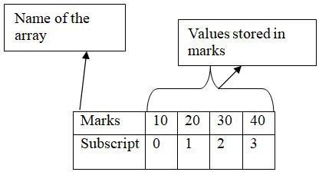

DECLARATION OF ARRAYS
Declaring an array means specifying three things:
- Data type – what kind of values it can store, for example int, char, float,double
- Name – to identify the array
- Size – the maximum number of values that the array can hold
Syntax: type name[size]; Example: int marks[5];
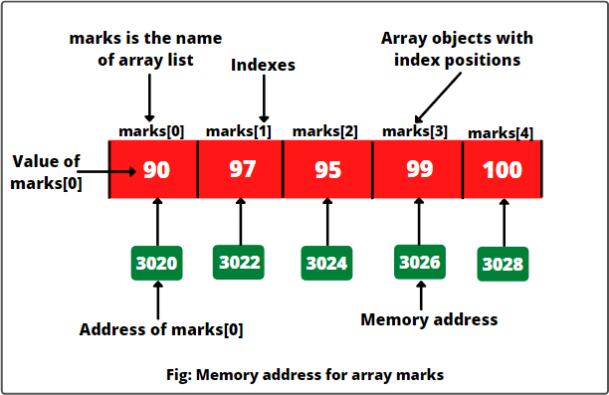

In C, the array index starts from zero. The first element will be stored in marks[0], the second element is stored in marks[1] and soon.

ACCESSING THE ELEMENTS OF ANARRAY
Accessing the array element is done using a loop statement in combination with printf statements or any other processing statements. Example of accessing the array elements and calculating total marks is given below:
Example code to initialize each element of the array to 1. int i,marks[10];
for(i=0;i<10;i++)
marks[i]=1;

In the for loop, first the value of marks[0] is set to 1, then the value of marks[1] and so on. The procedure is continued until all the 10 elements of the array is set to 1.

CALCULATING THE ADDRESS OF ARRAY ELEMENTS
Array name is the symbolic reference to the address of the first byte of the array. The subscriptortheindexrepresentstheoffsetfromthebeginningofthearraytotheelementbeing referenced. To calculate the address of array elements, the formula used is

A[k]= BA(A) + w(k-lower_bound)
Here, A is the array
k is the index of the element for which we have to calculate the address BA is the base address of the array A
w is the word size of one element in the memory lower_bound is the index of the first element of the array

Example: Given an array int marks[]= {99,67,78,56,88,90,34,85}. Calculate the address of marks[4] if base address=1000.
Word size is 2bytes because its an integer. A[marks[4]] = BA(A) + w(k-lower_bound)
= 1000+2(4-0) = 1008

CALCULATING THE LENGTH OF AN ARRAY
Lengthofthearrayisgivenbythenumberofelementsstoredinit.Thegeneralformula to calculate the length of the array is:
Length= upper_bound – lower_bound +1

Where upper_bound is the index of the last element and lower_bound is the index of the first element in the array.

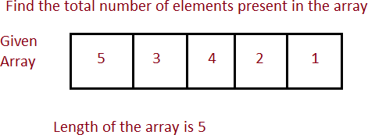

Length= upper_bound – lower_bound +1
= 4 – 0 + 1 = 5

STORING VALUES IN ARRAYS
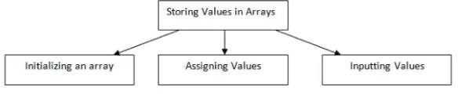
When we declare an array, we are just allocating space for the elments, no values are stored in the array. There are 3 ways to store values in array.

Initializing Arrays during Declaration
Elements of the array can also be initialized at the time of declaration. When an array is initialized, the value of every element of the arrays should be provided.
Syntax:
data_type_name array_name[size] = {value1,value2, };
Example 1:
int rollno[6] = {10, 11, 12, 13, 14, 15};
Here, you are initializing an array of int which is ‘rollnno’ , having 6 elements.
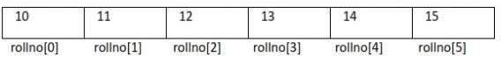
Example 2:
int rollno[6] = {10, 11, 12};
Here, only 3 elements are initialized are given, hence the remaining values are initialized to zero.

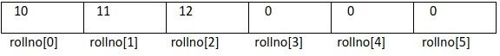
Example 3:
int rollno[6] = {};
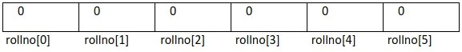

Example 4:
int rollno[] = {10, 11, 12, 13, 14, 15};

While initializing the array at the time declaration, the programmer may omit the size of the array. Here, the compiler will allocate enough space for all initialized elements.

Inputting values from the keyboard
An array can be filled by inputting the values from the keyboard. This can be done using looping statements.
int i, marks[5];
for (i=0; i<5; i++)
{
scanf("%d", &marks[i]);
}
In this loop, the iteration starts from 0 to 4 i.e it fills the values from first till last elements.

Assigning the values to individual elements
The third way is to use assignment operator in order to give elements their respective values. Any value that evaluates to the data type of the array can be assigned to the individual array element.
Example:
rollno[0] = 1;
Here, we are assigning value 1 st element of the array to 1.
//code to copy an array at the individual element level

int i,arr1[10],arr2[10]; arr1[10]={0,1,2,3,4,5,6,7,8,9};
for (i=0; i<10; i++)
arr2[i]=arr1[i];

//code to fill an array with even numbers int i,arr1[10];
for (i=0; i<10;i++)
arr1[i]=i*2;

OPERATIONS ON ARRAYS
There are number of operations that can be performed on arrays. These operations include the following:
- Traversing an array
- Inserting an element in anarray
- Deleting an element in anarray
- Merging twoarrays
- Searching an element in anarray
- Sorting anarray

Traversing an array
Traversinganarraymeansaccessingeachandeveryelementofthearrayforthespecific purpose.
Algorithm for array traversal
Step 1: [INTIALIZATION] SET I=lower_bound Step 2: Repeat Steps 3 to 4
While I<upper_bound Step 3: Apply Process to A[I]
Step 4: SET I=I+1
[END OF LOOP] Step 5: EXIT
Iisinitlaizedto lower_boudnofthearray.Awhileloop isexecuteduntilIvalueisless than the upper_bound value. Step 3 process the individual array elements as specified by the array name and indexvalue.
Example: Write a program to read and display n numbers using an array.

#include <stdio.h> void main()
{
int arr[10],i,n; clrscr();
printf("enter the number of elements"); scanf("%d", &n);
printf("enter elements in the array :\n"); for(i=0; i<n; i++)
{
printf("element - %d : ",i);
scanf("%d", &arr[i]);
}

printf("\nElements in array are: "); for(i=0; i<10; i++)
{
printf("%d \t ", arr[i]);
}

}

Output:
enter the number of elements: 10 enter elements in the array :
element - 0 :1
element - 1 :1
element - 2 :2
element - 3 :3
element - 4 :4
element - 5 :5
element - 6 :6
element - 7 :7
element - 8 :8
element - 9 :9

Elements in array are: 1 1 2 3 4 5 6 7 8 9

Inserting an element in an array
Inserting an element in an array means adding a new data element to an already existing
array.
- Algorithm to append a new element to an existing array.
Step 1: Set upper_bound= upper_bound +1 Step 2: Set A[upper_bound]=VAL
Step 3: EXIT
For example, consider an array marks[] holding 12 values and a new values has to be added.
Then we can do the same by marks[13]=45;
Now, the upper_bound value was 12 which was updated to 13 and the value for marks[13] is assigned.

- Algorithm to insert an element in the middle of anarray
The algorithm INSERT will be declared as (A,N,POS,VAL) where A is the array in which element has to be inserted, N is the number of elements in the array, POS is the position at which the element has to be inserted and VAL is the value that has to be inserted
Step 1: [INITIALIZATION] SET I=N
Step 2: Repeat steps 3 and 4 While I>=POS
Step 3: SET A[I+1]=A[I] [END OF LOOP]
Step 4: SET N=N+1
Step 5: SET A[POS]=VAL Step 6: EXIT

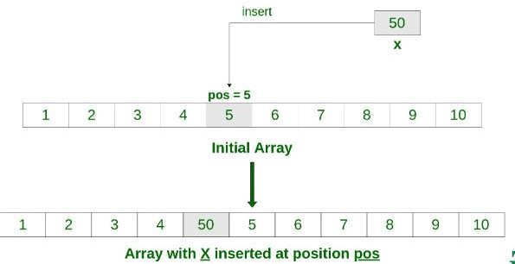
Example: Write a program to insert a number at a given location in an array #include <stdio.h>
int main()
{
int array[50], position, i, n, value;

printf("Enter number of elements in the array\n"); scanf("%d", &n);
printf("Enter %d elements\n", n); for (i = 0; i < n; c++)
scanf("%d", &array[i]);
printf("Please enter the location where you want to insert an new element\n"); scanf("%d", &position);
printf("Please enter the value\n"); scanf("%d", &value);
for (i = n - 1; i >= position - 1; i--) array[i+1] = array[i];
array[position-1] = value; printf("Resultant array is\n"); for (i = 0; i <= n; i++)
printf("%d\n", array[c]); return 0;
}

Output:
Enter the number of elements in the array 5
Enter 5 elements
1 2 3 4 5
Please enter the location where you want to insert a new element 3
Please enter the value 7
Resultant array is
1 2 3 7 4 5

Deleting an Element from anArray
Deleting an element from an array means removing a data element from an already existing array.
Algorithm to delete the last element of an array Step 1: SET upper_bound = upper_bound – 1 Step 2: EXIT

Forexample, ifthereare54studentsandthestudentwithrollnumber54leavesthecoursethen we should just decrement theupper_bound.

Algorithm to delete an element from the middle of an array.

The algorithm DELETE will be declared as (A,N,POS) where A is the array in which elementhastobeinserted,Nisthenumberofelementsinthearray,POS istheposition at which the element has to beinserted,

Step 1: [INITIALIZATION] SET I=N
Step 2: Repeat steps 3 and 4 While I>=n-1
Step 3: SET A[I]=A[I+1]
Step 4: SET I=I+1
[END OF LOOP] Step 5: SET N=N-1
Step 6: EXIT
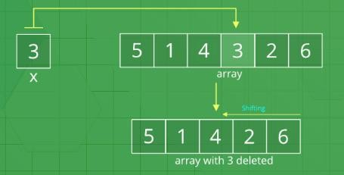

Program:
#include <stdio.h> #include <conio.h> int main()
{
int i, n, pos, arr [10]; clrscr ();
printf("\n Enter the size of the array:"); scanf("%d",&n);
printf("\n Enter the elements of the array: "); for(i=0;i<n;i++)
{
scanf("%d", &arr[i] );
}
printf("\n Enter the position from which the number has to be deleted: "); scanf ("%d", &pos );
for(i= pos; i<n-1;i++)
{
arr[i] = arr [i+1]; n--;
printf("\n The array after deletion is:");
}
for(i=0;i<n;i++)
{

printf("\n Arr[%d] = %d", i, arr[i]);
}
getch(); return 0;
}

Output:
Enter the size of the array: 5 Enter the elements of thearray:
1 2 3 4 5
Enter the position from which the number has to be deleted: 3 The array after deletion is:
Arr[0]=1 Arr[1]=2 Arr[2]=3 Arr[3]=5

MERGING TWO ARRAYS
Merging two arrays in a third array means first copying the contents of the first array intothethirdarrayandthencopyingthecontentsofthesecondarrayintothethirdarray.Hence, the merged array contains contents of the first array followed by the contents of the second array.

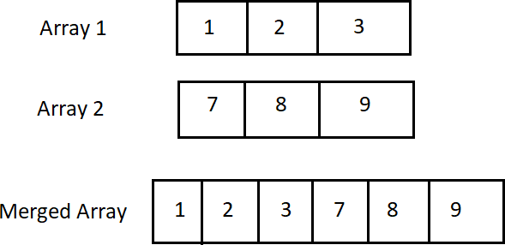

Merging of two unsorted array

Write a program to merge two unsorted arrays # include < stdio.h >
intmain( )
{
int a1[25], a2[25], a3[50],n1,n2,i,m,index=0;
printf(" Enter the number of element in first array : ") ; scanf("%d ",& n1) ;

printf("\n Enter the element of araay : \n") ; for ( i = 0 ; i < n1 ; i++)
scanf("%d ",& a1[i]) ;
printf(" Enter the number of element in second array : ") ; scanf("%d ",& n2) ;
printf("\n Enter the element of araay : \n") ; for ( i = 0 ; i < n2 ; i++)
scanf("%d ",& a2[i]) ; m = n1 + n2 ;
for ( i = 0 ; i <n1 ; i++)
{
a3 [index] = a1[i] ; index++;
}
for ( i = 0 ; i <n2 ; i++)
{
a3 [index] = a2[i] ; index++;
}
printf("\n Element of array after merging:\n") ; for ( i = 0 ; i <m ; i++)
pcanf("%d \t",a3[i]) ; return ( 0 ) ;
}
Output:
Enter the number of elements of the array 1:3 Enter the elements of the first array
10 20 30
Enter the number of elements of the array 2 :3 Enter the elements of the second array
15 25 35
Element of array after merging
10 20 30 15 25 35

Merging of two sorted arrays

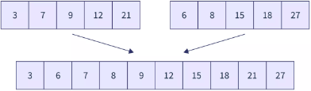

Write a program to merge two sorted arrays
#include <stdio.h> int main()
{
int n1,n2,n3, i = 0, j = 0, k = 0; int a[10], b[10], c[20];
printf("Enter the size of first array: "); scanf("%d",&n1);
printf("Enter the array elements: "); for(int i = 0; i < n1; i++)
scanf("%d", &a[i]);
printf("Enter the size of second array: "); scanf("%d",&n2);
printf("Enter the array elements: "); for(int i = 0; i < n2; i++)
scanf("%d", &b[i]); n3 = n1 + n2;
while (i < n1 && j < n2)
{
if (a[i] < b[j])
{
c[k] = a[i]; i++;
}
Else
{
c[k] = b[j]; j++;
} k++;
}
while (i < n1) c[k++] =a[i++];
while (j < n2) c[k++] =b[j++];
printf("Final array after merging: "); for(int i = 0; i < n3 ; i++)
printf(" %d ",c[i]); return 0;
}
Output:
Enter the size of first array: 4
Enter the array elements: -2 0 45 86 Enter the size of second array: 6

Enter the array elements: -7 -5 56 78 109 112
Final array after merging: -7 -5 -2 0 45 56 78 86 109 112

SEARCHING FOR A VALUE IN AN ARRAY
Searching means to find whether a particular value is present in the array or not. If the value is present in the array then search is said to be successful and the search process gives the location of that value in the array. Otherwise, if the value is not present in the array, the search process display the appropriate message saying search is unsuccessful

LINEAR SEARCH
Linear search is a very basic and simple search algorithm. In Linear search, we search an element or value in a given array by traversing the array from the starting, till the desired element or value is found.

Algorithm: LINEAR_SEARCH(A,N,VAL) Step1: [INTIIALIZE] SET POS=-1
Step 2: [INTIIALIZE] SET I=1
Step 3: Repeat Step 4 WHILE I<=N Step 4: IF A[I]=VAL
SET POS=I PRINT POS
Go to Step 6 [END OF IF] SETI=I+1
[END OF LOOP] Step 5: IFPOS=-1
Print “value is not present “ [END OF IF]
Step 6: EXIT Program:
#include<stdio.h> void main( )
{
int n, a[100], i, key,loc; loc=-1;
printf("Enter the size of the array\n"); scanf("%d",&n);
printf("Enter the elements of array\n"); for(i=0;i<n;i++)
scanf("%d",&a[i]);
printf("Enter the key element to be searched\n"); scanf("%d",&key);
for(i=0;i<n;i++)
{

if(key == a[i])
{
loc=i+1; break;
}
if(loc>=0)
printf("The element %d is found at %d \n",ele,loc);
else
printf("The search is unsuccessful\n");

}

Output:
Enter the size of the array 5
Enter the elements of array
12 25 8 10 32
Enter the key element to be searched 3
The element 8 is found at 3

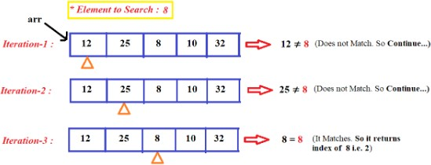

BINARY SEARCH

Binary search works only on a sorted set of elements. To use binary search on a collection, the collection must first be sorted. The array is divided into two parts, compared with middle element if it is not successful, then it is compared whether it is lesser or greater than middle element. If it is lesser, search is done towards left part else right part.

Algorithm: BINARY_SEARCH(A,lower_bound,upper_bound,VAL)
Step1: [INTIIALIZE] SET BEG=lower_bound, END=upper_bound, POS=-1

Step 2: Repeat Step 3 and 4 WHILE BEG <= END Step 3: SET MID = (BIG + END)/2
Step 4: IF A[MID]=VAL, then POS=MID
PRINTPOS
Go to Step6
ELSE IF A[MID]>VAL, then SET END=MID – 1
ELSE
SET BEG=MID + 1
[END OF IF]

[END OF LOOP] Step 5: IF POS=-1
Print “value is not present “ [END OF IF]
Step 6: EXIT

Program:
#include<stdio.h> void main( )
{
int n, a[100], i, key, loc, high, low, mid; loc=-1;
printf("Enter the size of the array\n"); scanf("%d",&n);
printf("Enter the elements of array in sorted order\n"); for(i=0;i<n;i++)
scanf("%d",&a[i]);
printf("Enter the key element to be searched\n"); scanf("%d",&key);
low=0; high=n-1;
while(low<=high)
{
mid=(low+high)/2; if(key==a[mid])
{
loc = mid+1; break;
}
else

if(ele<a[mid]) high=mid-1;

else low=mid+1;
}
}
if(loc>=0)
printf("The element %d is found at %d \n",ele,loc); else
printf("The search is unsuccessful\n");
}

Output:
Enter the size of the array 5
Enter the elements of array in sorted order 1 2 3 4 5
Enter the key element to be searched 4
The element 4 is found at 4
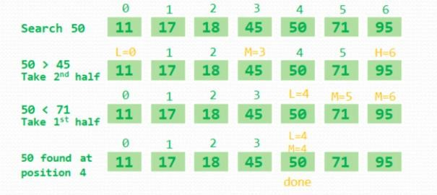

PASSING ARRAYS TO FUNCTIONS
We can pass arrays to a function like any other variables.

Passing individual Elements
The individual elements of an array can be passed to a function by passing either data values or their addresses.

Passing Data Values

The individual elements can be passed in the same manner as we pass variables of any other data type. The condition is just that the data type of the array element must match with the type of the function parameter.
main()
{
int arr[5]={1,2,3,4,5};
func(arr[3]);
}
void func(int num)
{
printf(“%d”,num);
}

In the above example, only one element of the array is passed to the calling function.
Single element arr[3] is passed to the function.

Passing Address
Address of an individual array element can be passed to the function using the addres operator(&).
main()
{
int arr[5]={1,2,3,4,5};
func(arr[3]);
}
void func(int*num)
{
printf(“%d”,*num);
}
In the above example, the address of the fourth element is passed to the calling function.
In the called function the value of the array element must be accessed using the indirection (*) operator.

Passing the Entire Array
When we need to pass an entire array to a function, simply pass the name of the array. In cases where we do not want the called function to make any changes to the array, the array must be received as a constant array by the called function. This prevents any type of unintentional modifications of the array elements.
main()
{

int arr[5]={1,2,3,4,5};
func(arr);
}
void func(int arr[5])
{ inti;
For(i=0;i<5;i++) printf(“%d”,arr[i]);
}
Write a program to read and print an array of n number using function #include <stdio.h>
void read_array(int arr[], int); void display_array(int arr[], int); void main()
{
int arr[10],n;
printf("Enter the size of the array :\n"); scanf("%d", &n);
read_array(num,n); display_array(num,n); getch();
}
void read_array(int arr[10], int n);
{ int i;
printf("Enter the elements in the array :\n"); for(i=0; i<n; i++)
{
scanf("%d", &arr[i]);
}
}
void display_array(int arr[10], int n);
{ int i;
printf("The elements in the array are:\n"); for(i=0; i<n; i++)
printf("%d \t", arr[i]);
}
}

Output:
Enter the size of the array: 5
Enter the elements of the array: 1 | 2 | 3 | 4 | 5
The elements of the array are :1 | 2 | 3 | 4 | 5

